Task 1: Establishing Database Connections write a Java program that connects to a SQLite database and prints out the connection object to confirm successful connection.

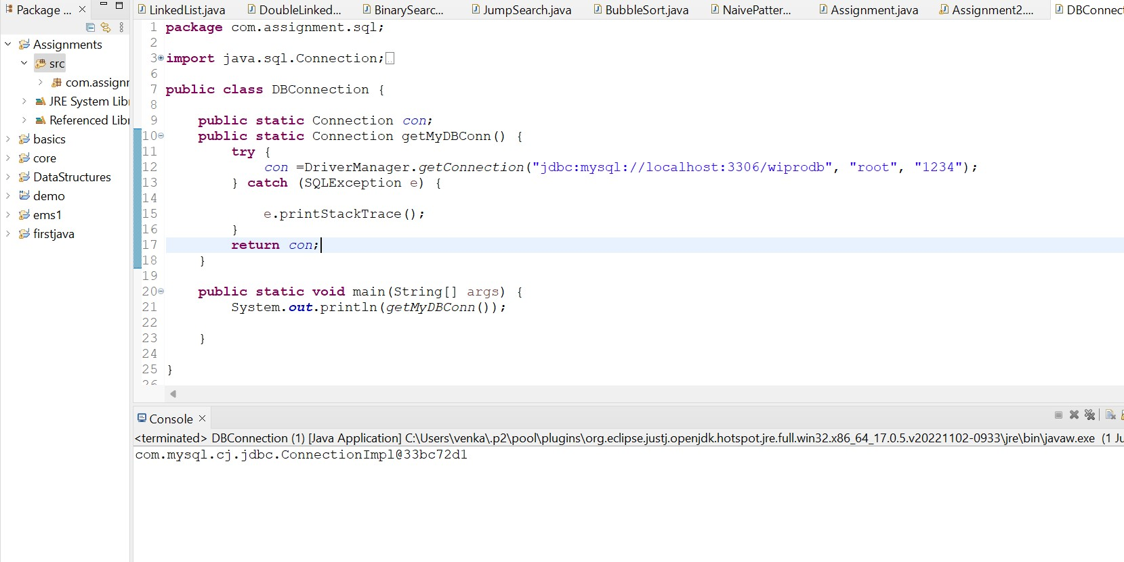

Task 2: SQL Queries using JDBC

Create a table 'User' with a following schema 'User ID' and 'Password' stored as hash format (note you have research on how to generate hash from a string), accept "User ID" and "Password" as input and check in the table if they match to confirm whether user access is allowed or not.

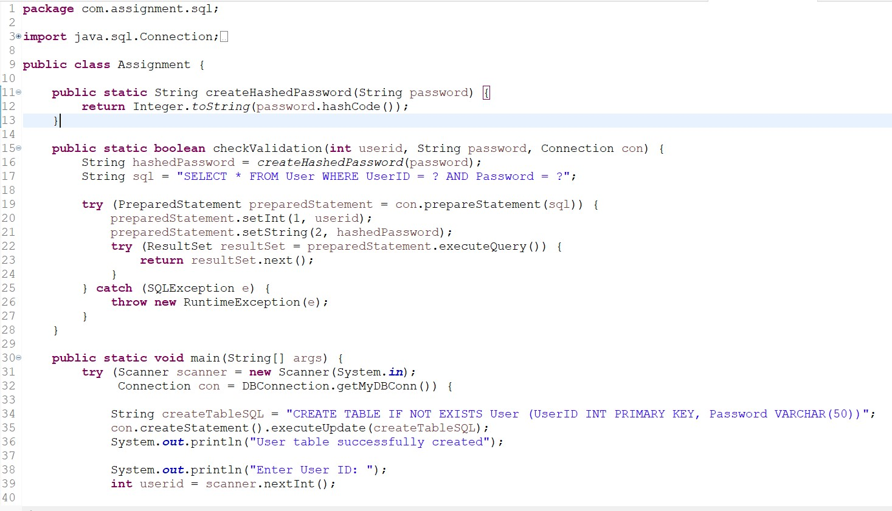

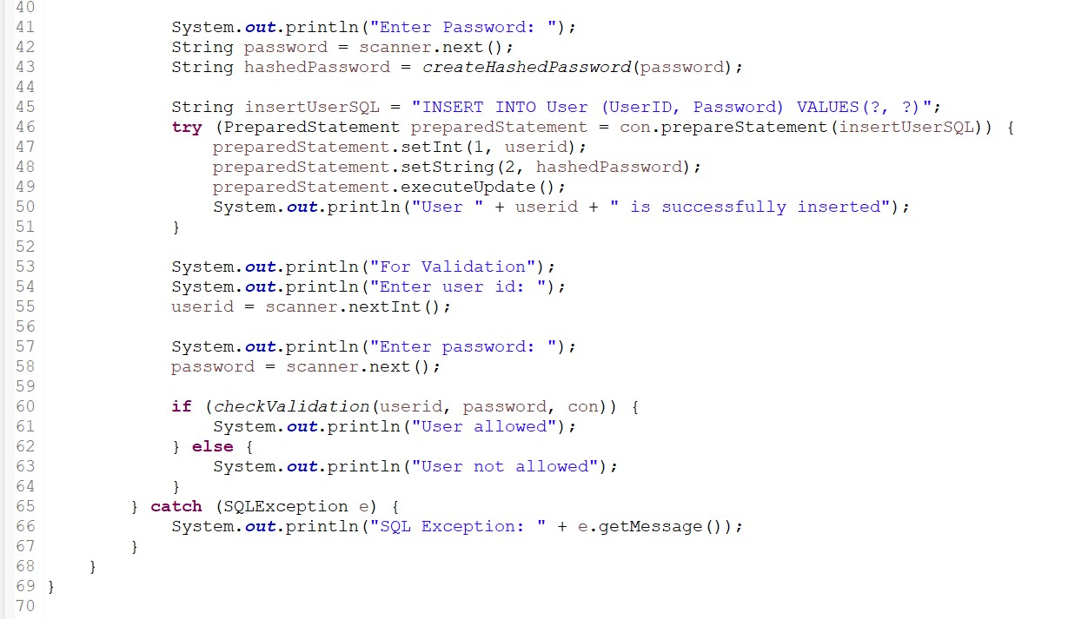

Output:

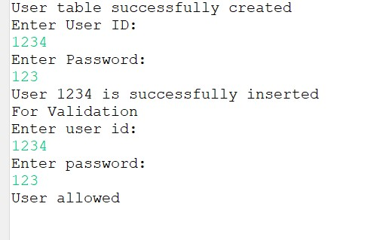

Task 3: PreparedStatement

Modify the SELECT query program to use PreparedStatement to parameterize the query and prevent SQL injection.

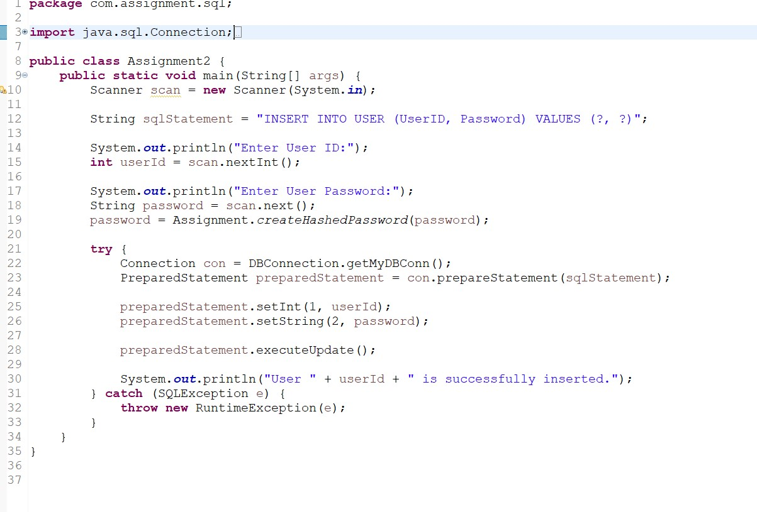

Output:

